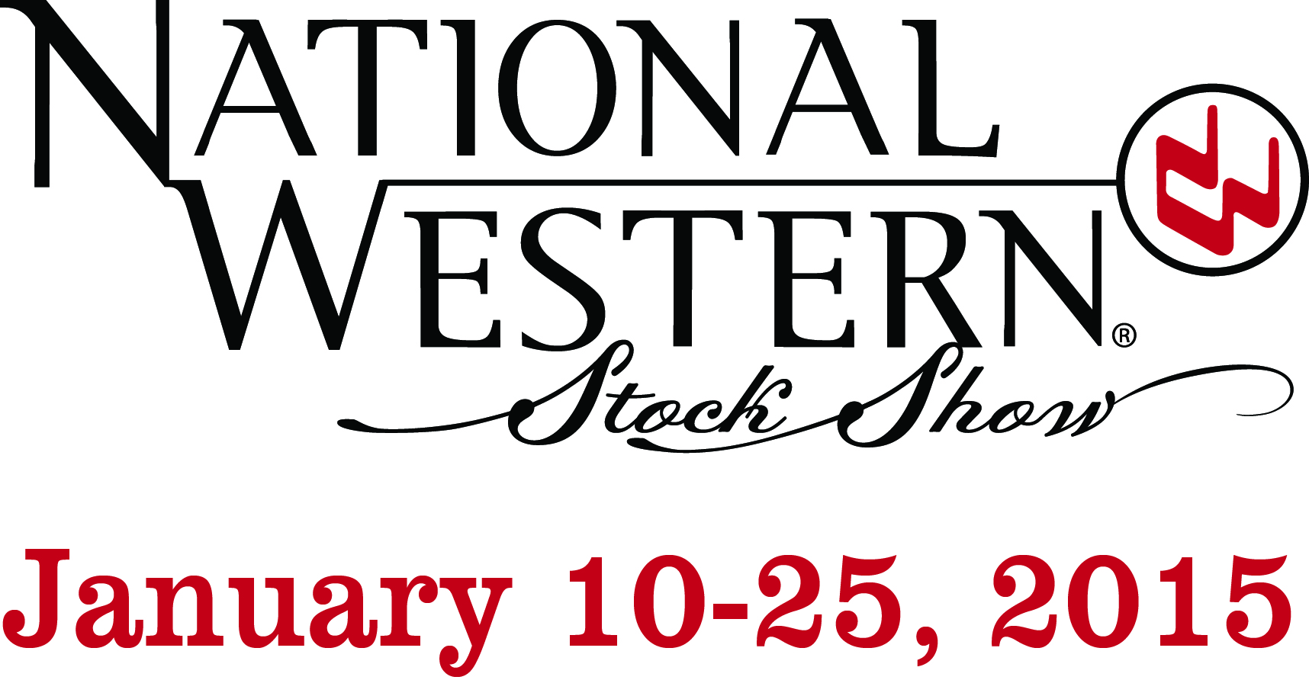

For Immediate Release: January 23, 2015 Contact: Karen Woods
kwoods@nationalwestern.com
303-299-5522

Top Eight Junior Livestock Champions go for $319,000

Denver, Colo. –The 2015 Auction of the Junior Livestock Champions brought out the top bidders, with the small animals winning big. The top eight champion animals posted total sales of $319,000. The auction started with a bang when the Reserve Grand Champion Hog sold for $34,000, nearly doubling last year’s bid by $16,000. The Grand Champion Hog sold for $36,000, exceeding last year’s bid by $6,000.

The money invested supports the junior exhibitors that raised the animal as they plan for their agricultural future and college educations. In addition, a portion of the proceeds support the National Western Scholarship Trust, which funds scholarships in agriculture and rural medicine at colleges throughout Colorado and Wyoming. This year 80 students received funds to aid their education.

The top six Junior Livestock animals were auctioned off live on 9News at 6:30pm. The results of the eight champions are listed below:

- The Grand Champion Steer sold for $100,000 to a brand new bidder Calcon Constructors, Inc. The steer was shown by 17-year-old, junior exhibitor Shilo Schaake, from Westmoreland, Kansas.
- Kent P. Stevinson bought the Reserve Grand Champion Steer for $55,000, shown by 11- year-old Triniti Scott from Burlington, Colorado.

- The Grand Champion Hog sold for $36,000 to Anadarko Petroleum Corporation. The junior exhibitor is 11-year-old Garrison Straka from Yukon, Oklahoma.

- The Reserve Champion Hog was sold for a record -setting $34,000 to the Denver Metro Chamber of Commerce and shown by 16-year-old Madison Lynch from Cleveland, Texas.
- The Grand Champion Lamb went for an all-time record of $40,000 to Transwest Trucks, Inc. and was shown by 17-year-old Jenna Frink of Eaton, Colorado, a youth exhibitor with aspirations to attend Colorado State University.

- The Reserve Grand Champion Lamb went to Colorado Business Bank for all-time record of $23,000. The junior exhibitor is 16-year-old Laura Winn of Moriarty, New Mexico.
- The Grand Champion Goat went to EKS&H, LLLP for $16,000 and was shown by 13-year -old Aspen Martin from Mason, Texas.

- The Reserve Grand Champion Goat shown by 18-year-old Brandon Schovanec of Garber, Oklahoma was bought by STEPS Foundation for $15,000.

******About the National Western Stock Show******
In the 109th year, the National Western Stock Show is a 501(c) (3) charitable organization that provides college and graduate level scholarships in agriculture and medicine for practice in rural areas. It is also our mission to serve producers and consumers throughout the world by being the premier Stock Show, Rodeo, Horse Show and center for year-round events. The 16-day show also serves as an entertainment arena, hosting one of the world's richest regular season professional rodeos, largest horse show and Colorado's largest western trade show. For more information visit nationalwestern.com.

