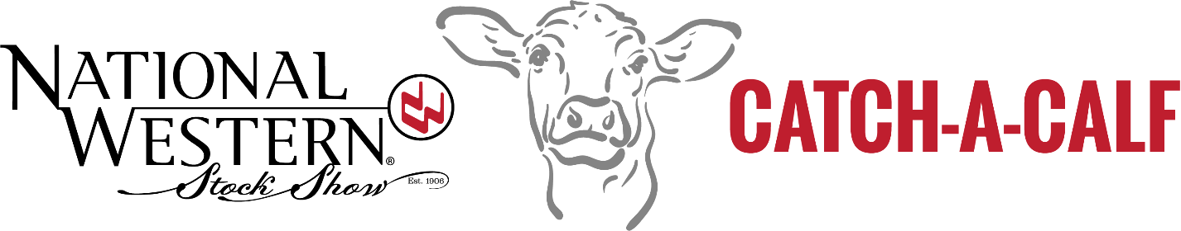
program handbook

Western Stock show association
Catch A Calf Program

Table of Contents

CATCH-A-CALF CONTACT INFORMATION…………………….…………..………………………….2

POLICY STATEMENT………….…………………..…………………..……….………....…………..3

GOOGLE CLASSROOM INSTRUCTIONS…………..………………..………………..…..………..4-5

RECORD BOOK, PROGRAM SUMMARY & SCORING..…………..……………..….……...…..6-17

NWSS ENTRY INFORMATION..………………..………………………..………..…………..….…18
RETURNING TO NWSS IN JANUARY……………..………………….…………………..………….19
STEER ISSUES……………………………..………..…………………..…………………..….…….20

Catch-A-Calf • Contact Information

SUPERINTENDENT CONTACT INFORMATION:
Michele Erikson
970-302-3333
nwsscac@gmail.com

Mikayla Gabel
970-573-1165
nwsscac@gmail.com

COMMITTEE CHAIRMAN:
Ben Duke
303-912-2067
ben@firerockcattle.com

NATIONAL WESTERN STOCK SHOW STAFF CONTACTS:
Clint Chitsey
Vice President of Livestock Operations
cchitsey@nationalwestern.com

Jennifer Boka
Sr. Director of Livestock Operations
jboka@nationalwestern.com

Brandi Fuller
Livestock Operations Coordinator
bfuller@nationalwestern.com

National Western Stock Show
Attn: Livestock Dept.
4655 Humboldt St
Denver, CO 80216
(O) 303-299-5559

Catch-A-Calf • Policy Statement

The purpose of the Catch-a-Calf Program is to teach life skills and help youth develop values that will enable them to become contributing, productive citizens.

Livestock and other animal projects provide a great learning experience for youth. Exhibiting livestock competitively should develop a sense of exemplary and humane animal care and husbandry. Animal projects require a commitment to honest competition, proper feeding and care of animals, and service as an ambassador for the livestock industry.

Emphasis on winning at any cost, carried to the point of artificial enhancement of desirable traits, is contradictory to the very basis of youth livestock program. Cheating entails unfair competition and works against industry efforts to improve livestock. It also demeans animal agriculture and other youth participants by negating the objectives of stewardship and ethical behavior.

Practices counter to humane animal husbandry will not be tolerated in programs associated with the National Western Stock Show.

Failure to complete all requirements of the project may result in forfeiture of premium and/or sale money. This will be determined by the National Western Stock Show staff and the CAC Superintendents.

The Western Stock Show Association reserves the right to confiscate any calf from any member who does not abide by these rules, does not cooperate with the Catch-A-Calf Superintendents and the National Western Staff, or does not properly feed and care for the calf. If any calf is confiscated, no allowances will be made for any expenses incurred. This decision will be at the discretion of the Catch-A-Calf Superintendents, Committee Members, and the National Western Stock Show staff.

Google Classroom • Instructions for Catch-A-Calf
Class code: 6zikc37o
Google Classroom will be used to submit a variety of items for Catch-a-Calf. This will include submitting your monthly letter to be judged (you will still mail a copy to your sponsor) and your monthly progress forms.
Here are the steps to being added to the CAC Google Classroom:
- Go to http://classroom.google.com. Then click the blue sign-in button in the center.
- If you already have a Google Account you will simply need to sign in. If you do not, click the link to “Create an Account”. If you do have to create an account there is an option under the box to choose a username that allows you to use an existing email address (doesn’t have to be Gmail) or you can certainly create one. If you create an account it will ask you to verify it.
- You will continue to Google Classroom. Your screen should look like this below, click the + sign on the top right corner, then “Join Class.” You will enter the class code, which is 6zikc37o, and then join.

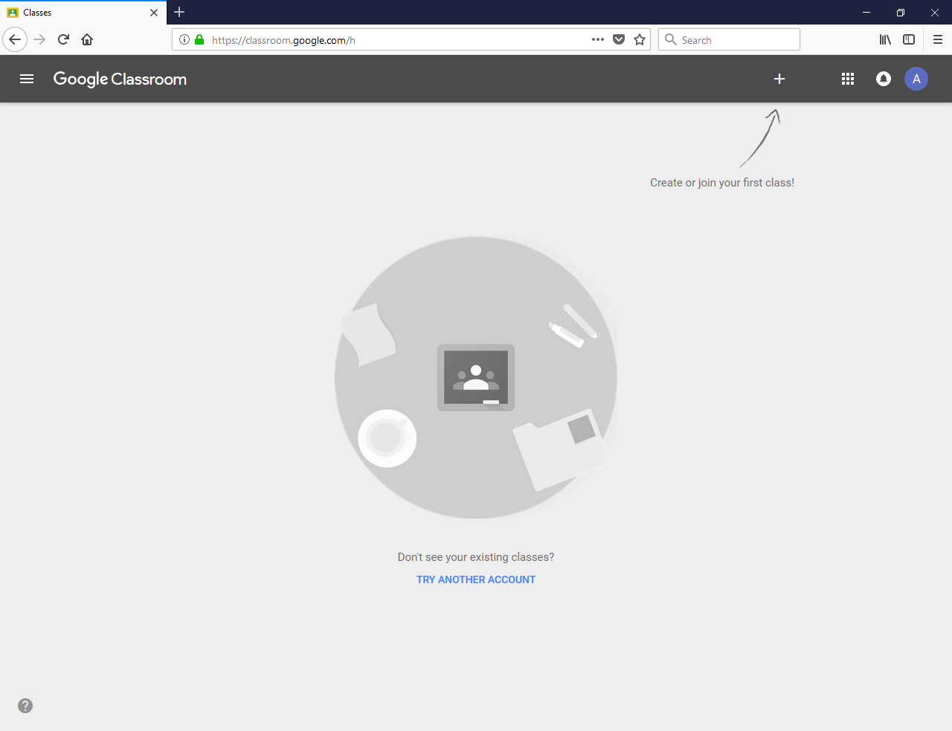

- Once you’ve joined the class your screen should look similar to this:

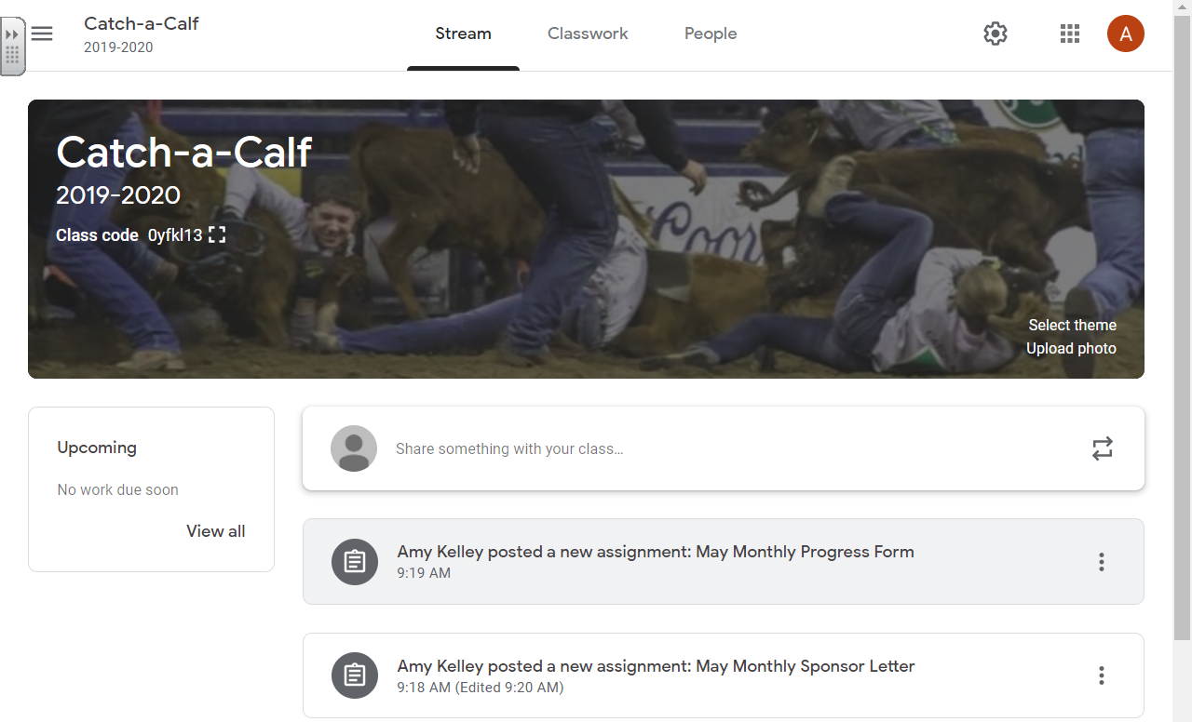

- Your “assignments” each month will be posted for you to turn in. Specific instructions for submitting the monthly progress form and the sponsor letter will be given later.

REMINDERS FOR GOOGLE CLASSROOM:

Monthly Sponsor Letter – FILE SAVING: Use yourname.month (ex. johndoe.june)

Class code: 6zikc37o

[ ANY questions concerning Google Classroom contact nwsscac@gmail.com ]

Catch-A-Calf
Record Book, Program Summary & Scoring

PROGRAM SUMMARY

This practical beef production program will be scored as follows and the results will be announced immediately following the conclusion of the Catch-A-Calf Show at the National Western Stock Show.

- Sponsor Relations (40 points)
- Record Book (50 points)
- Industry Performance (10 points)
- Interview (25 points)
- Live Animal Evaluation (live show at the National Western Stock Show) (max 10 points)
- Showmanship (live show at the National Western Stock Show) (max 20 points)
- Deadlines Met (Budget, Monthly Progress Forms, and NWSS Entry Forms) (5 points)
- Carcass (Note: carcass data will be collected from all steers following the show and the results will be mailed out at a later date)

Two (2) Catch-A-Calves will qualify for the NWSS Junior Livestock Champions Sale, using a point system based on the sections listed above. In order for a calf to be eligible for the Junior Livestock Sale the calf must place in the top four of their live placing class. If a tie occurs, it will be broken using Interview Division scores.

SPONSOR RELATIONS
40 POINTS
*YOU MUST UPLOAD A COPY OF YOUR LETTER EACH MONTH TO OUR GOOGLE CLASSROOM ALONG WITH SENDING TO YOUR SPONSOR*
(see instructions for submitting documents to our Google Classroom)

REQUIREMENTS: Each month you must write a one or more page letter to your sponsor and email or mail to your sponsor(s). The letter must also be uploaded to the classroom by the last date of the month. Point(s) will be deducted for letters that are not submitted by the last day of the month. You have at least 30 days each month to submit letters on time and receive full credit.

Each letter is eligible to receive 5 points. A total of 8 letters are required for a maximum of 40 points. Points will be awarded based on the following criteria:

- Readability/overall appearance/on time/1 full page (single spaced, 12pt font) 1 point
- Information about family, school, 4-H, or other personal activities 2 points
- Information about your calf (weight, ADG, behavior, feeding program, etc) 2 points

Each letter received will be scored.
Those individuals with the top three scores based upon the 8 letters will be awarded plaques.

MONTHLY SPONSOR LETTER

Your monthly sponsor letter will be submitted via Google Classroom for Catch-a-Calf. Here are the instructions for uploading your monthly sponsor letter to Google Classroom:

- You will write a monthly letter to your sponsor and email or mail to them (depending on what they request). However, for judging purposes you will need to submit a copy of that letter to Google Classroom. You have two options to create your monthly letter. Regardless of what option you select you will need to save your letter as yourname.month.
  - You can create the letter as a Google Doc and save it in your Google Drive.
  - You can create the letter as a Word document and save it on your computer.

- From the main page of the Catch-a-Calf Google Classroom you can see all “assignments” for the month. You will click on that month’s sponsor letter.
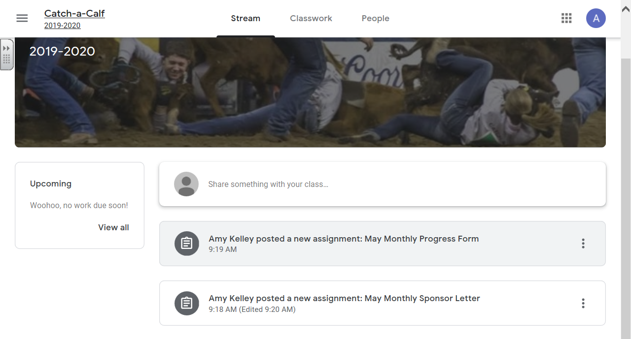

- The screen that comes up looks like the following. Once you are in the assignment itself you will click the Add button.

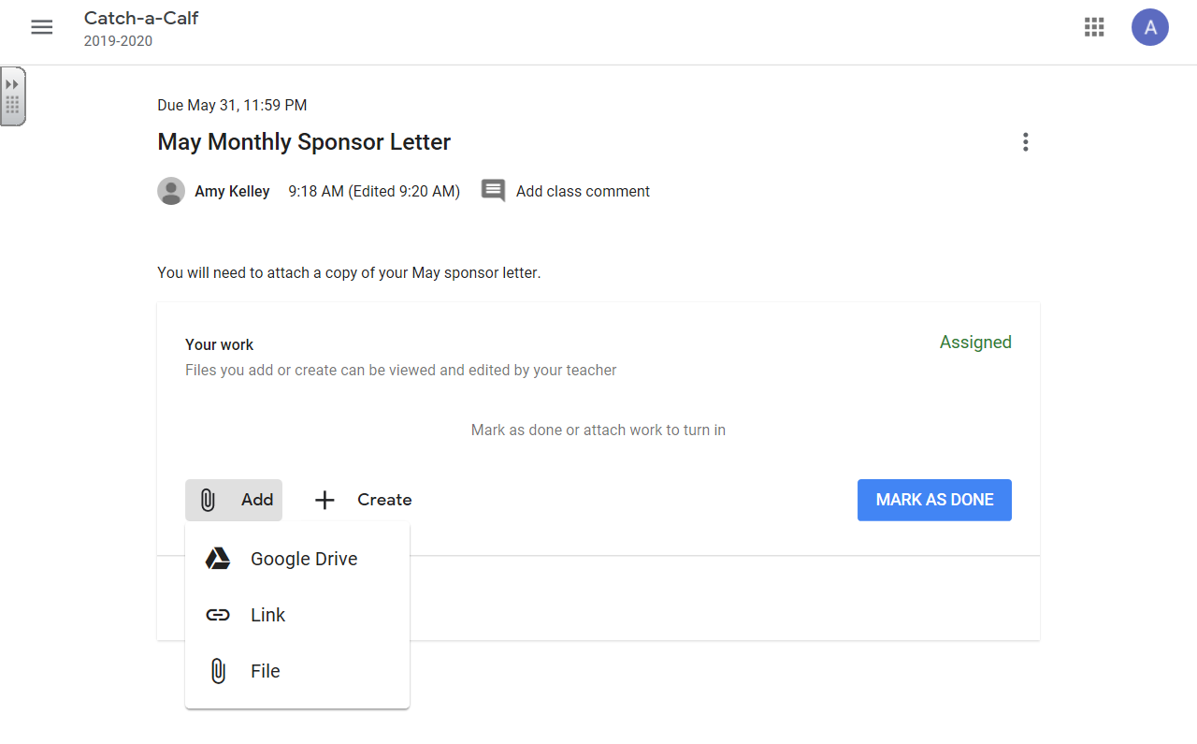

- You have two options for adding your letter.
  - If you used Google Docs and saved it on your Google Drive, you’ll select Google Drive. You can think find the letter and click the blue “Add” button.
  - If you used a Word document, you’ll select File. When you select to add as a File it will say insert files using Google Drive (even though you are uploading), you want to choose the box that says, “Select Files from Your Computer.” You’ll select the file you want then hit the blue “Upload” button.
Now all you need to do is click the blue “Turn In” button. It will double check you want to submit. If you need to edit you will hit the Unsubmit button. If you need to do that be sure to resubmit it. Once you’ve submitted your Monthly Sponsor Letter you will see Turned In on the top right of that assignment.

Important Information regarding letters:
- The first letter is to be written in May after you receive your calf (letter 1). DUE BY MAY 31.
- You are responsible for sending your letter to your sponsor(s)!!!
- Monthly letters are required thereafter (June, July, August, September, October, November, and December). Points are deducted for late letters!
- No letter required in January, prior to the NWSS.
- A thank you letter must be sent after the NWSS and the copy of the letter must be sent to: NWSS, c/o Livestock Office, 4655 Humboldt St., Denver, CO 80216

IMPORTANT: You will NOT receive your premium or market value check until you submit a final thank you letter after the NWSS. You must send one to your sponsor(s) AND a copy of it (them) to the NWSS Livestock Office. It will not count toward this category, but the NWSS must receive a copy of your thank you letter in order to release the check from the sale of the steer.

Guidelines for Successful Letter Writing:
- TURN LETTERS IN ON TIME!!! (Submitted by the last day of the month)
- Be professional.
- Use these letters as a way to introduce yourself to your sponsor. They would like to know what else you are involved in, outside of this project. Include details about your life: Sports, school, 4-H, clubs, family, animals, work, etc.
- Include detailed information about your calf. If you are having any challenges, this is how the Catch-A-Calf Committee will find out about the challenge. Examples include:
  - Calf’s weight (you should be weighing often)
  - What and how much you are feeding your calf; Average Daily Gain
  - Expenses
  - Progress or setbacks with your steer
  - Health issues
  - Activities you do with your calf
- Spell check your letters.
- Pay attention to proper grammar.
- Use the following format to help you develop your letters:
  - Heading: this section should include the address of your sponsor
  - Greeting: this section addresses your sponsor (Dear Mr./Ms./Dr. _______)
  - Body: this section is where you will provide information about yourself and your calf
  - Closing: this is where you provide your closing statement (ex. Sincerely) followed by your signature or name (if electronic).
Example of a High-Quality Sponsor Relation Letter:
Mr. & Mrs. John Smith
1234 North Highway ABC
Anywhere, ST 12345
June 14, 2022

Dear Mr. & Mrs. Smith,

Hello again! How are you doing? Are you enjoying this beautiful summer weather? I am definitely enjoying my summer. I have taken advantage of the nice weather and I have planted lots of flowers in our yard. My family and I really enjoy growing a garden every year and so we have once again planted a garden. I enjoy watching the plants grow and change every day! My little brother does not like all of the work that is involved with planting flowers and vegetables, but he definitely likes it when he finally gets to eat the vegetables.

It has been two weeks since school ended and I do not miss it one bit! What I do miss is seeing my friends every day and being involved with school activities. I only get to see my friends one or two days a week during the summer. We try to get together and stay at each others house at least one night a week. Also, we also all play on the same summer league softball team. During the summer we aren’t very competitive, we just like to get together and have fun.

I will be gone from home almost all of next week. I am going to the State 4-H Convention with my county 4-H delegation. There are 8 kids from our county that are going. Almost all of us are on the Jr. 4-H Council. Have I told you yet that I am the President? It is a lot of work, but it is well worth the time and effort. I was voted into the position by my peers, which was quite an honor.

While I am gone from home my dad and older brother are going to take care of my steer, Concho. In exchange for my brother helping me out while I am gone, I have to take care of his pigs and horse while he is at basketball camp. Concho is doing great!! He has adjusted well to his new home. At first he was very cautious about everything and he would get spooked easily. Now he acts like he owns the place! I am having a little trouble getting him used to the halter. I can finally get it on his head without him causing a fuss. However, I can’t yet get him to walk with me using the halter. Dad said that once I get back home from camp, we will really start working with him. Concho doesn’t mind being tied up if I brush on him. He was also very scared of the brush at first! Now he loves it! I am feeding Concho twice a day. He gets ___ lbs of steer show feed at each feeding. He also gets about ___ lbs of alfalfa hay each day. On June 12th he weighed _____lbs. That means he has an ADG of ____lbs/day since I picked him up at the breakfast. I need to record his weight in my record book frequently.

Before I forget, I wanted to invite you and your family to our annual summer BBQ. Every year my entire family gets together at our house and we invite our friends and neighbors and we have a great time!! It will be on the 4th of July. If you would like to attend please call me and I can give you specific directions to our house.

I hope you both are doing great and I look forward to hearing from you soon!
Catch A. Calf

RECORD BOOK DIVISION
50 POINTS

All successful businesses keep accurate and complete records. These records help them to make good business decisions. The Record Book Division is designed to help you learn good record keeping skills and to increase the understanding of your project by monitoring your animal’s performance. Your record book is available on Google Classroom.

IMPORTANT: You may work on your record book directly through Google Docs and everything automatically saves after every edit you make. You may also export the record book to Excel to work on it. Always be sure to save a blank copy so that you always maintain a blank original.

MONTHLY PROGRESS FORM
MONTHLY EXPENSES + PROJECT UPDATE

Each month you will be asked to complete a Monthly Progress Form (including January). The forms are due by the last day of the month (with the exception of January, for which the deadline will be sent out in advance). Turning them in on time is worth .5 points each time, so you’ll want to be sure and get them submitted in time. Also, the Monthly Progress Form counts towards your total record book score. The expense part is worth 2 points each month and the performance information and project update is worth 1 point each month.

There are three parts to the Monthly Progress Form, Monthly Expenses, Performance Information, and Project Update. The Monthly Expenses part includes all expenses that month. You'll be asked to report Feed Expenses, Health Expenses, Supplies & Equipment Expenses, and Other Expenses. Feed Expenses include all feed purchased (both grain and hay). Health Expenses includes any medication purchased, vet visits, health papers, etc. Supplies & Equipment Expenses would include equipment, show supplies, etc. Other Expenses can include show entries, pasture rental, transportation, etc. It is important to be accurate with your expense tracking. If for some reason you don’t have an expense that month you need to put none or $0 and not leave that blank. The Performance Update asks you to record weight, ADG, feed purchased, and feed fed. The Project Update will have you answering some questions in regard to your CAC project. Questions should be answered in complete sentences and all questions answered. The information from the Monthly Progress Form feeds into your Record Book in the Monthly Progress Summary, so be sure to record there as well.

The Monthly Progress Form will be submitted through the Google Classroom for Catch-a-Calf. Here are instructions for completing and submitting your Monthly Progress Form:

- The Monthly Progress Form is a Google Form. Each month there will be a new Form assigned.
- From the main page of the Catch-a-Calf Google Classroom you can see all “assignments.” You will click on that month’s Monthly Progress Form assignment.

- The screen that comes up looks like the following. You will click on the Google Form for that month, and it will take you to the actual Google Form.
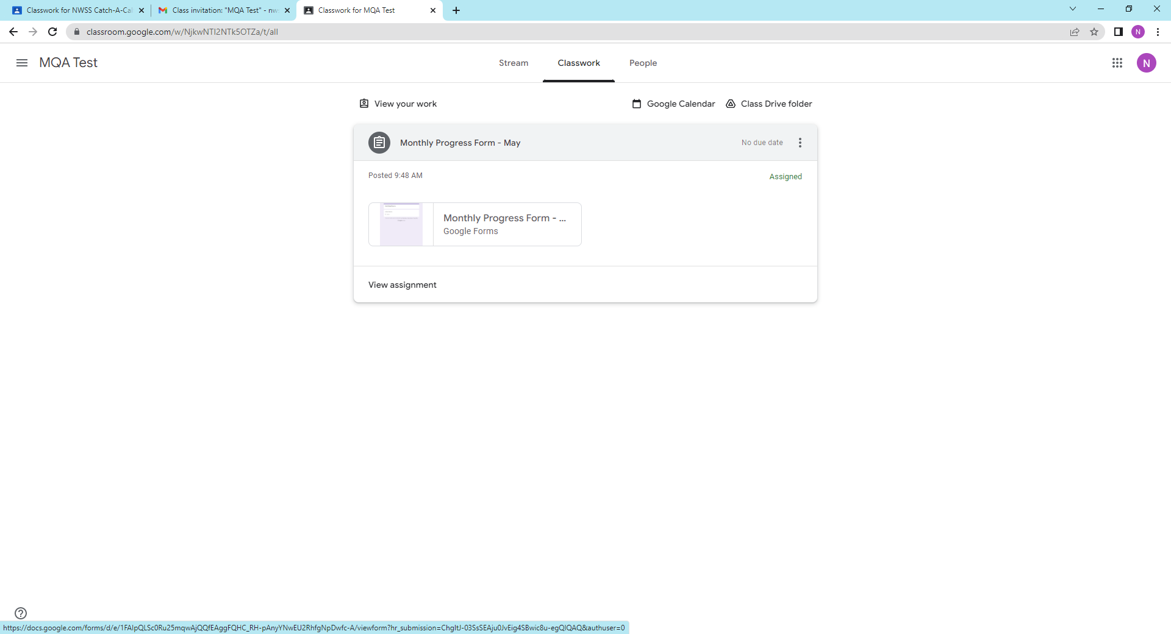

- Once you get to the end of the Monthly Progress Form you will click on Submit and it will automatically submit it for the month. Please note you will receive an email response with what you put in as answers, but it is also important to put the same information in your Monthly Progress Summary for your record book.
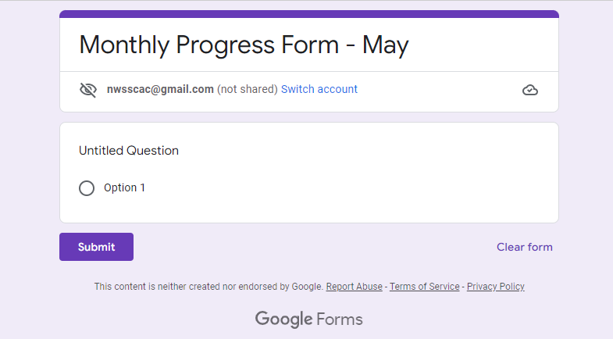

- Once you’ve submitted your Monthly Progress Form you will see “Turned In” in the top right corner of that month’s assignment. Please mark that you’ve turned it in. Again, you will not be able to see the information you’ve put into the Google Form, so very important you put it in your Monthly Progress Summary in your record book.

The Catch-A-Calf Record Book contains the following pages (worksheets in Excel):
1. FILE SAVING: You may work on your record book directly through Google Docs and everything automatically saves after every edit you make. You may also export the record book to Excel to work on it. Always be sure to save a blank copy so that you always maintain a blank original.
2. MARGINS: Make sure that all page margins are set to 1 inch top and bottom; and 0.75 inch on the left and right side.
3. 9 SECTIONS: This record book has 9 sections (listed below). The first 7 sections have "Worksheets". Each worksheet is identified by an individual tab located at the bottom of this spreadsheet. The following is a list of the sections:
INSTRUCTIONS: This is an informative page that you do not have to print off. Refer back to this page for additional instructions.
COVER PAGE: You and your parent/guardian will sign at the conclusion of the program.
GOALS: You will submit 3 goals, 1 personal & 2 program related by April 30th. Goals must be SMART in nature.
BUDGET: This page is designed to help you develop a budget for the project and estimate profit/loss. The budget should be submitted by April 30th. However, you will also need to save those figures to be submitted with your record book at the completion of the project.
INVENTORY: An inventory helps you determine what you have on hand at the beginning and closing of the project. Include items that are donated to you.
MONTHLY PROGRESS SUMMARY: This page summarizes expense information and feed information from the Monthly Progress Forms submitted monthly via Google Classroom. These expense totals are used in the Financial Summary, so accuracy is important.
PERFORMANCE SUMMARY: This is an important page as it will be used to determine how well your calf performs relative to industry standards. Pay careful attention to your calculations on this page! Include a minimum of 4 entries.
FINANCIAL SUMMARY: These values will come from your monthly progress forms. You will need to total each month's expenses and transfer to this page. You will also add in income and calculate profit and loss.
TREATMENT: On this page, you will keep track of all medicine or chemicals administered to your animal. You will need to know how much was given, by whom, and if there is a withdrawal date. Everyone should have at least one entry in this category.
PROJECT STORY: Include a typed, written story (12 point font, double spaced) that is at least one page. The story should include knowledge gained, goals, accomplishments, and struggles.
PROJECT PHOTOS: Include 2 pages of pictures (front and back) that show progress during the year. The pictures MUST be captioned.
NOTE: When finalizing your Record Book, you compile the sections in the order listed above.
OTHER NOTES:
Google Docs & Excel can help you with calculations. To enter a formula into a cell, you must type an equal sign (=) followed by the command. Excel HELP can help you format these formulas.
FOLLOW THESE DIRECTIONS FOR KEEPING YOUR CATCH-A-CALF RECORD BOOK:
Goals: Practical livestock feeding program that incorporates animal nutrition, money management, record keeping, personal management, responsibility, daily care, relationships with others (sponsors, creditors, etc).
Start your record book as soon as you get home; you already have records to document (weight, beginning value, etc.)
Prepare a good, safe place to house and feed your calf. We encourage participants to feed quality feeds, but as economically as possible. We suggest you start your steer off slowly with a receiving ration for the first two weeks, feeding only 4-5 pounds of grain and some good quality grass hay. As soon as your steer has adjusted you will need to increase the amount of feed.
You are required to send in a Monthly Progress Form by the last day of each month. This form includes information about monthly expenses and project updates.
Properly kept records provide an up-to-date account of the project at all times and make it possible to have an accurate and complete summary when the project is finished.
Your project will not be considered complete until after your steer is weighed in January at the National Western Stock Show. Your record book will be evaluated in this program on details, accuracy, readability, and completeness. Follow these guidelines to complete your records. Bring your up-to-date record book and project log when you come to the National Western Stock Show. After the calves are weighed, you will complete the final parts of your record book. Record books are due at the National Western Stock Show. It is most practical to write records in pencil so corrections can be made or keep your records on a computer.
If you do not have information for one of the categories – indicate “not applicable” or “N/A” on that section. That way you will receive full credit and the judges will know that you didn’t skip that section.

GUIDELINES FOR SUCCESSFUL RECORD KEEPING:
The following are principles to keep in mind when keeping your Catch-A-Calf Record Book:
- Records are kept for future reference.
- Records are kept on a regular basis with legible entries (ex. Monthly).
- This should be a working record book – it’s okay for it to look worn and used, it doesn’t have to be in perfect condition.
- Entries should be made neatly and accurately.
- Entries should be brief, but with enough detail to avoid confusion
- Dates should be for a specific day (ex. May 21, 2023), not just a month and year.
- Entries must reflect actual prices paid or income generated.
- Provide all information requested and in the units requested.
- You may print/photocopy extra pages as needed.
- The story should be about what you learned from this project, what challenges you faced and what you accomplished. The story should be interesting to the reader.
- Photos should be taken at various stages of the project (beginning, mid-point, end).
- The Meat Quality Assurance makes the Treatment Record extremely important. You must keep accurate records of all medicines given to your animal.

National Western Stock Show
Catch-A-Calf Program
Record Book Scoresheet

Member’s Name: |  | Calf Number:
Record Book Page |  |  | Points Possible |  | Points Awarded
Budget & Goals (completely filled out, accurate, realistic) |  |  | 3
Inventory (completely filled out, accurate, realistic, totals done) |  |  | 2
Monthly Progress Forms & Summary (completed each month, accurate, totals done, all questions answered.) |  |  | 24
Presentation (How is your record book presented? Ex. Creativity, organization, etc.) |  |  | 5
Performance Summary (completely filled out, accurate, realistic, totals done, minimum of 4 entries) |  |  | 4
Treatment Record (complete, accurate, appropriate entries) |  |  | 1
Project Story (demonstrates knowledge gained, includes goals and accomplishments, etc.)  *Format – Full page, double spaced, typed in 12pt font |  |  | 3
Project Pictures (no more than 2 pages (front and back), shows progress of project, includes captions) |  |  | 2
Financial Summary (completely filled out, accurate, totals done) |  |  | 4
Overall Quality (completeness, readability, accuracy, including agents signature on cover) |  |  | 2
Totals: |  |  | 50

Comments:

INDUSTRY PERFORMANCE DIVISION
10 POINTS
Many factors determine profitability for commercial cattle feeders. The Industry Performance Division is designed to reflect factors that are important to profitability. For the purposes of this program, the entire feeding period will be used (May through January). The scoring for this division is based upon the Performance Summary pages from your Record Book.
The following is a description of the four categories involved in this division:
Final Weight Relative to Industry Standards (4 points):
Live weight for market cattle is an important part of commercial cattle feeding. An average of the final weights will be used to create the point system. Full points awarded vary year to year, so the goal of the participant should be not to hit a certain weight for points, but the ideal finish weight for their steer. Steers weighing under 1000 pounds will receive 0 points.
Feed Conversion (3 points):
Feed Conversion (feed efficiency) refers to how many pounds of feed it takes to produce one pound of live weight gain. Typically growing/finishing beef cattle use 5-7 pounds of feed for every pound of live weight gain.
Your feed conversion will be compared with the average of the other calves in this program. For example, if your steer’s feed conversion is 6 pounds of feed per pound of gain, and the average of the Catch-A-Calf steers is 8 pounds of feed per pound of gain, then you would receive more points than the average, since your feed conversion was more desirable (lower). The Performance Summary page of your record book will walk you through how to calculate the feed conversion.
Cost of Gain (3 points):
Cost of feeding (feed, labor, animal health expenses) is a driving factor in profitability, especially when compared to the amount of gain. Currently in the commercial feeding industry, the cost per pound of live weight gain is generally less than $1.20 (per pound of gain). Your project differs from commercial cattle feeding due to the higher cost for feed when purchasing small packages of feed (one sack at a time) as opposed to tons of bulk feed. Additionally, your steers will not gain like steers in a feedlot, as you will be exercising and working with your animal regularly. However, by understanding the different products available and paying attention to how much these feed products cost, you can be successful!
Your cost of gain will be compared with the average of the other calves in this program. For example, if your cost of gain is $1.25, and the average of the Catch-A-Calf steers is $1.50, then you would receive more points than the average, since your cost of gain was more desirable (lower). The Performance Summary page of your record book will walk you through how to calculate the cost of gain.
The following is a demonstration of how the type of ration you feed can greatly affect your cost of gain for cattle. Consider the following two examples. Ration A uses average quality alfalfa hay, whole corn, and a protein block. Ration B uses the same hay and a manufactured show steer grain mix. The example is for a 900-pound steer that is gaining over 2.5 lbs per day.

INTERVIEW DIVISION
25 POINTS
The interview portion of the project will take place at the National Western Stock Show. The purpose of the interview is for the Catch-A-Calf committee to have the opportunity to speak with each contestant individually and ask questions about the project experience. Additionally, by participating in the interviews, each participant will have the opportunity to develop their public speaking and interview skills.
The interview will last no longer than 5 minutes. Each contestant will be required to use the first 2 minutes to give a speech on the designated topic. The topic of the speech will be announced at a later date. The remaining 3 minutes of the interview may be used by the panel of judges to ask the contestant questions about the CAC project and the beef industry.
The interview is worth 25 points total. The speech is worth a maximum of 10 points and the questions are worth a maximum of 15. Each judge will score the contestants separately and the scores will be averaged together to determine the contestants' final score.
Example Questions:
- What is the most important thing you learned from this project and how will you use that in the future?
- What is something that you would like to change about this project?
- What was the most difficult aspect of this project? Why?
- Who assisted you with this project the most and what did they do?
- What was your goal for your steer’s ending weight and did you meet that?
- How do you play a role in the beef industry?
- Would you recommend this program to one of your friends? Why?
- How much weight did your steer gain from the day that you received it?
- Do you project that you will make or lose money in this project?
- Do you believe that this project was a success for you?
- What is the number one thing you wanted to achieve through this project?

LIVE EVALUATION & SHOWMANSHIP DIVISIONS
10 MAXIMUM POINTS (Live Evaluation) & 20 MAXIMUM POINTS (Showmanship)
All steers will be weighed at the National Western Stock Show. Based upon this weight, steers will be divided into 4 classes for the live show. Classes will be ranked by a qualified judge as to the following parameters:
- Potential carcass merit (based upon muscling and fat cover of the animal)
- Soundness and structural design
Maximum of 10 points will be awarded in Live Placing (1st – 10, 2nd – 9, 3rd- 8, 4th- 7, 5th- 6, 6th-5, 7th-4, 8th-3, 9th -2, 10th-1. Remaining steers receive 0 points). Steer must place in the top 4 of the class to be eligible for Jr. Livestock Auction.
Showmanship phase will be broken into classes based upon the age of the exhibitors. Showmanship classes will be held separate from the lives placing classes. A maximum of 20 points will be awarded (1st-20, 2nd- 18, 3rd- 16, 4th- 14, 5th-12, 6th -10, 7th-8, 8th-6, 9th-4, 10th-2. Remaining showmen receive 0 points).

CARCASS DIVISION
Note: carcass data will be collected from all steers following the show and the results will be mailed out at a later date)
Immediately following the Catch-A-Calf show, calves will be loaded on a truck to be shipped to the packing plant. Carcass data will be collected from the steers and all data from the steers will be ranked by the same index used for the Fed Beef Contest at the National Western Stock Show. It will take several weeks to get the data collected, analyzed, and distributed back to the exhibitors! Please be patient.

AUCTION OF JUNIOR LIVESTOCK CHAMPIONS
Two (2) calves from the Catch-A-Calf program will qualify for the Auction of Junior Livestock Champions at the National Western Stock Show. These two calves, which will be designated Grand Champion and Reserve Grand Champion Catch-A-Calves, will be selected using a point system which includes: Record Book – 50 pts., Sponsor Relations – 40 pts., Interview – 25 pts., Production – 10 pts., Lives Placing – pts., Showmanship – 20pts., Deadlines Met – 5 pts., with a possible 160 pts.
The two calves must have placed in the top 4 of live placing. In the case of a tie, it will be broken using participants' interview scores. The participant will receive the buyback price minus deductions required by state regulations, such as, but not limited to Colorado Beef Board, Colorado Brand Board, freight charges, etc. From the remaining portion of the sale price, 20% to the participant, 30% distributed to various aspects of the Catch-A-Calf Program and 50% to be divided between the rest of the participants.
(Participants who do not complete their project, may not be eligible for their portion of the 50% from the two sale calves; this will be at the discretion of the CAC Superintendents and the NWSS Livestock office to make the final decision on completion of the project.) THESE TWO CALVES WILL ALSO BE DRUG TESTED FOR FOREIGN AND PROHIBITED SUBSTANCES.

NWSS Entries – DUE NOVEMBER 1

You will be sent all of the entry instructions for the 2026 National Western via email later in the Fall.

DUE NOVEMBER 1:
- Online entry
- Premise ID Number (apply for your Premise ID online – Google “Premise ID (your state). It’s free!)

You will also receive a Meat Quality Assurance form that you are required to get signed and completed that is due at processing at the NWSS in January. DO NOT SUBMIT THIS FORM WITH YOUR ENTRIES. YOU WILL TURN IN YOUR MEAT QUALITY ASSURANCE IN JANUARY.

Need to complete a meat quality assurance course? Contact your Extension Agent, FFA Advisor or 4-H Leader about a local class you can take. OR visit yqca.org to get certified online!
Unlike all of the other junior market species at the NWSS, Catch-A-Calf entries do not submit DNA.

Checklist Upon Return to NWSS in January
om
[ ] BRAND PAPERS
You may or may not be from a brand state or brand area of your state. Except for CO, if you are from a brand state or brand area of your state, you will need to get new brand papers issued before your return to the National Western in January.
You must bring the original brand paper you were given in May.

[ ] HEALTH PAPERS
You MUST get issued a new health paper (CVI – Certificate of Veterinary Inspection) within 30 days of your arrival back to the NWSS in January. We strongly suggest not waiting until the last minute to call your veterinarian for health papers.
You MUST have a clean health paper (CVI) issued within 30 days of January 6th. The negative BVD test result is printed on your ORIGINAL health paper given to you in May.

[ ] BVD – DO NOT RETEST YOUR STEER
Your steer has already tested negative for BVD before you picked it up in May. This is stated on the original health paper you were given in May. There is no need to re-test your steer for BVD. Simply show the original health paper to your veterinarian and you are good to go.
Keep your original health paper for negative BVD test proof.

[ ] PREMISE ID NUMBER
A Premise ID Number is required for your entry paperwork with the National Western. You can aquire your number by Google searching “Premise ID (your state” (ex. Premise ID Colorado). It takes a few weeks to get the number, so we strongly encourage you to apply early.
This is required for your entries! Google search “Premise ID (your state)” to apply – it’s free!

[YOUR NWSS ENTRIES ARE DUE NOVEMBER 1ST]

Issues with Steer

STEERS HEALTH: If you have questions regarding the health of your steer, contact your local veterinarian immediately. Remember to document any treatment(s) given to your steer in your record book and in your monthly letter. Please be aware of label usage and withdraw dates.

STEERS BEHAVIOR: After you pick up your steer in May, you should expect to spend a lot of time and effort halter breaking and taming your steer. It can take several weeks before your steer is comfortable with its new surroundings and with the idea of being halter broke. If you are having problems with your steers' behavior, contact a local 4-H Beef Leader, Extension Agents or Ag Teacher for suggestions and assistance. If you continue to have issues after two months, please contact Michelle, Mikayla or the NWSS Livestock Staff.

STEERS DEATH: If your steer dies, you need to immediately contact a superintendent AND NWSS Livestock Staff. You will also need to contact your sponsor(s) and inform them.

* Depending on the circumstances, if your steer is removed from your possession due to behavior or death, you may have the option to continue the program or be eligible to participate in the program the following year. If the superintendents and NWSS Livestock Staff approve of this, it will be your responsibility to complete and submit a new application for next year.

